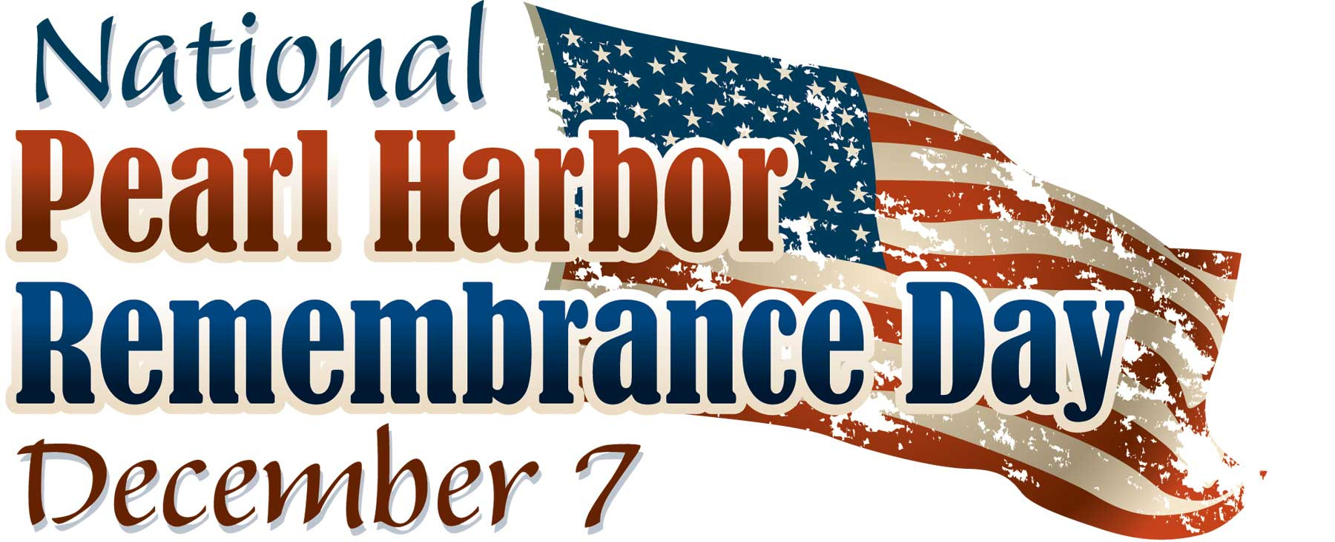

Lone Star Wing Dinner
BYOB Happy Hour 6:30 p.m. / Dinner 7 p.m.
Speaker to follow dinner
Location: Michelson Museum
216 N. Bolivar St.
Marshall, Tx
Cost: $25 per person
RSVP on form attached by Nov. 30
(email RSVP accepted with all information below included)

Menu: Tuscan Chicken OR Flat Iron Steak, Roasted Potatoes, Squash and Zucchini, Salad, Rolls, Buttermilk Chocolate Cake, Tea, Water, Coffee (Meal will be buffet style, chose one meat)

Name:______________________________________________________
Address:_____________________________________________________
Email:_______________________________________________________
Phone:______________________________________________________
Spouse:_____________________________________________________

Number in your party:___________

Choice of meat
Tuscan Chicken:_________ Flat Iron Steak:__________

You may also pay your dues at this time for 2018 - $50/member

Total Amount paid: $____________ Dinner $____________ Dues

Checks can be made out and mailed to:
CAF – LSW
4422 Rebel Lane Marshall, Tx 75672
We also accept credit cards (call me at 903-926-0788)

